**PENNSYLVANIA**

**PUBLIC UTILITY COMMISSION**

**Harrisburg, PA 17105-3265**

Public Meeting held May 14, 2009

Commissioners Present:

James H. Cawley, Chairman

Tyrone J. Christy, Vice Chairman

Kim Pizzingrilli

Wayne E. Gardner

Robert F. Powelson

|  |  |  |
| --- | --- | --- |
| Pennsylvania Public Utility Commission  v.  The Peoples Natural Gas Company, d/b/a,  Dominion Peoples |  | M-2009-2086651 |

# 

# Opinion and Order

**BY THE COMMISSION:**

Before the Commission for consideration and disposition is a Settlement Agreement (Settlement or Settlement Agreement) originally filed on January 23, 2009, by The Peoples Natural Gas Company, d/b/a Dominion Peoples (Dominion Peoples or the Company) and the Commission’s Law Bureau Prosecutory Staff (Prosecutory Staff) collectively, “the Parties,” with respect to an Informal Investigation conducted by the Prosecutory Staff. On April 24, 2009, the Parties filed a revised Settlement Agreement that clarified the point that the $5,000 civil penalty referenced in the Settlement Agreement is to be made to Low-Income Usage Reduction Program (LIURP) contractors while $30,000 is to be spent to create educational programs as described in the Settlement Agreement. The Parties submit that the proposed Settlement Agreement is in the public interest and complies with the Commission’s Policy Statement at 52 Pa. Code § 69.1201 (Factors and standards for evaluating litigated and settled proceedings involving violations of the Public Utility Code and Commission regulations—statement of policy). Settlement at 8, 11; ¶¶ 33, 44. Further, the proposed Settlement is submitted as contingent on Commission approval without any waivers, or other approvals to effectuate its terms. Settlement at 13; ¶ 51. If the Commission does not approve the Settlement without modification, either party may elect to withdraw from the Settlement.[1] Settlement at 14; ¶ 52.

**History of the Case**

The Settlement Agreement has been brought before the Commission by the Parties in order to resolve allegations of multiple violations of the Code of Federal Regulations and the rules and regulations of the Commission relative to natural gas pipeline safety. The specific incidents that are the subject of the Settlement Agreement occurred on May 2, 2007, June 8, 2007, and June 21, 2007.

On May 2, 2007, a contractor using a backhoe damaged a service line connected to a dwelling in Tyrone, Pennsylvania. Settlement at ¶¶ 12-13. A Commission Gas Safety Division Inspector subsequently found that Dominion had failed to follow proper procedure in abandoning the line. Settlement at 4; ¶¶ 14-15. If proven, this conduct would be in violation of 49 C.F.R. § 192.605(a), (b)(8) – Procedural Manual for Operations, Maintenance, and Emergencies; 49 CFR § 192.13(c) - General; 49 CFR 192.603 – General Provisions; 52 Pa. Code § 59.33(a) – Safety; and 52 Pa Code

§ 59.36(5) – Abandonment of Inactive Service Lines.

On June 8, 2007, a contractor damaged a pipeline in West Mifflin, Pennsylvania. A PUC Gas Safety Division Inspector subsequently discovered after a review of Dominion’s records that Dominion personnel did not accurately mark the

eight inch steel gas main in the proposed area of excavation and that the Dominion contract locator did not locate the pipeline because he misinterpreted the actual location of the pipeline on the map. Settlement at 5; ¶¶ 22-23. If proven, this conduct would be a violation of 49 C.F.R. § 192.614- Damage and Prevention Program and 52 Pa. Code

§ 59.33 (a) – Safety.

On June 21, 2007, a PUC Gas Safety Inspector inspected Dominion’s records related to valve maintenance at the Wilkinsburg, Altoona, and Kiski facilities located throughout Western Pennsylvania and found that three Dominion employees utilized for valve maintenance were not qualified and five employees had expired qualifications related to Federal and State Operator qualifications rules. Settlement at 5; ¶¶ 24-25. If proven, this conduct would be constitute violations for each employee for every day that each was so employed, but not qualified of 49 C.F.R. § 192.805 – Qualification Program.

An Informal Investigation was conducted pursuant to Subsection 331(a) of the Public Utility Code, 66 Pa. C.S. § 331(a), and Section 3.113 of the Commission’s Rules of Practice and Procedure, 52 Pa. Code § 3.113.

After the Informal Investigation, and in accordance with 52 Pa. Code § 3.113(b)(3), Prosecutory Staff and Dominion Peoples entered into discussions regarding settling this matter without the need for an on-the-record proceeding. Those discussions resulted in a proposed Settlement. Prosecutory Staff and Dominion Peoples jointly support the proposed Settlement. The Parties aver that the proposed Settlement is in the public interest and request that the Commission approve the Settlement.

Note, however, that at our Public Meeting of May 14, 2009, we adopted the Motion of Vice Chairman Tyrone J. Christy which recommended, subject to comment from interested parties, that Paragraph 31 A of the proposed Settlement be amended to reflect the manner in which Dominion Peoples manages its LIURP program. The proposed amendatory language to Paragraph 31 A of the Settlement reads:

To pay, in lieu of a civil penalty pursuant to 66 Pa. C.S. § 3301(c), five thousand dollars ($5,000) as an increment to the Commission-Approved 2009 LIURP budget of $610,000 establishing a revised 2009 LIURP budget of $615,000. The incremental $5,000 shall be administered by the outside contractor consistent with the current practice. The Company shall not claim or include any portion of this civil penalty amount in any future rate proceeding.

In addition to issuing the proposed Settlement as submitted for comment by interested parties, we directed that all interested parties be afforded an opportunity to comment with respect to whether Paragraph 31 A of the proposed Settlement should be revised in this fashion.

On May 28, 2009, subsequent to the Public Meeting of May 14, 2009, but before the entry of this Order, the Law Bureau and Dominion Peoples filed a joint letter with the Secretary of the Commission agreeing to amend the proposed Settlement to include the recommended amendment to Paragraph 31 A, above.

**Discussion**

Pursuant to our Regulations at 52 Pa. Code § 5.231, it is the Commission’s policy to promote settlements. The Prosecutory Staff provides a detailed analysis of the proposed Settlement in light of the Commission’s Policy Statement at 52 Pa. Code

§ 69.1201 (Factors and standards for evaluating litigated and settled proceedings involving violations of the Public Utility Code and Commission regulations—statement of policy). Settlement at 10-11. However, the Commission must review proposed settlements to determine whether the terms are in the public interest. *Pa. PUC v. Philadelphia Gas Works*, M-00031768 (January 7, 2004); 52 Pa. Code § 69.1201. Before the Commission conducts this review and rules on the Settlement, we must provide other potentially affected persons with the opportunity to submit comments thereon or to take other action provided for under law. 52 Pa. Code § 3.113(b)(3). This action must proceed despite that fact that the Law Bureau and Dominion Peoples have agreed to the proposed amendment of Paragraph 31 A.

**Terms of the Settlement Agreement**

The proposed Settlement contains a series of material terms summarized in this Opinion and Order, but those terms do not constitute an admission, a finding of any fact, or a finding of culpability on the part of Dominion Peoples in this or any other proceeding. Settlement at 6, ¶ 28.

In order to settle the Informal Investigation, Dominion Peoples has agreed to the following:

* 1. To pay, in lieu of a civil penalty pursuant to 66 Pa. C.S. § 3301(c), five thousand dollars ($5,000) as an increment to the Commission-Approved 2009 LIURP budget of $610,000 establishing a revised 2009 LIURP budget of $615,000. The incremental $5,000 shall be administered by the outside contractor consistent with the current practice. The Company shall not claim or include any portion of this civil penalty amount in any future rate proceeding.[2]
  2. To cease and desist from committing any further violations of gas safety regulations.
  3. To train and re-qualify its workers related to Abandonment of Inactive Service Line procedures. (The Parties assert that this training has already been completed).
  4. To train and re-qualify all its line locators. (The parties assert that this training has already been completed).
  5. To inspect all valves in all Dominion locations that were inspected between January 1, 2005 and December 31, 2007, by employees who were not qualified or properly re-qualified.
  6. To provide the Commission’s Gas Safety Division with a list of dates in which the re-qualification of employees performing valve maintenance covered tasks took place.
  7. To create and provide to schools within Dominion’s service territory an educational program directed at school children that addresses safety-related issues associated with natural gas.
  8. To create and provide an educational program directed at contractors who engage in subsurface excavation within Dominion’s service territory. This program will address safety-related issues associated with excavating in an area where Dominion has pipelines.
  9. To spend thirty thousand dollars ($30,000.00) to implement paragraphs G and H, above.

**Conclusion**

Before issuing a decision on the merits of the proposed Settlement Agreement, and consistent with the requirement of 52 Pa. Code § 3.113(b)(3), we are providing an opportunity for interested parties to file comments to the proposed Settlement and Application; **THEREFORE,**

**IT IS ORDERED:**

1. That this Opinion and Order together with the Settlement Agreement, as amended, shall hereby be entered for comments by any interested party.

2. That a copy of this Opinion and Order together with the attached Settlement Agreement, as amended, shall be served on the Office of Consumer Advocate and the Office of Small Business Advocate.

3. That comments to the Settlement Agreement, as amended, and this Opinion and Order will be considered timely if filed within twenty (20) days of the date of entry of this Opinion and Order.

4. That, subsequent to the Commission’s review of the comments filed in this proceeding, an Opinion and Order will be issued.



**BY THE COMMISSION,**

James J. McNulty

Secretary

(SEAL)

ORDER ADOPTED: May 14, 2009

ORDER ENTERED: September 10, 2009

ATTACHMENT

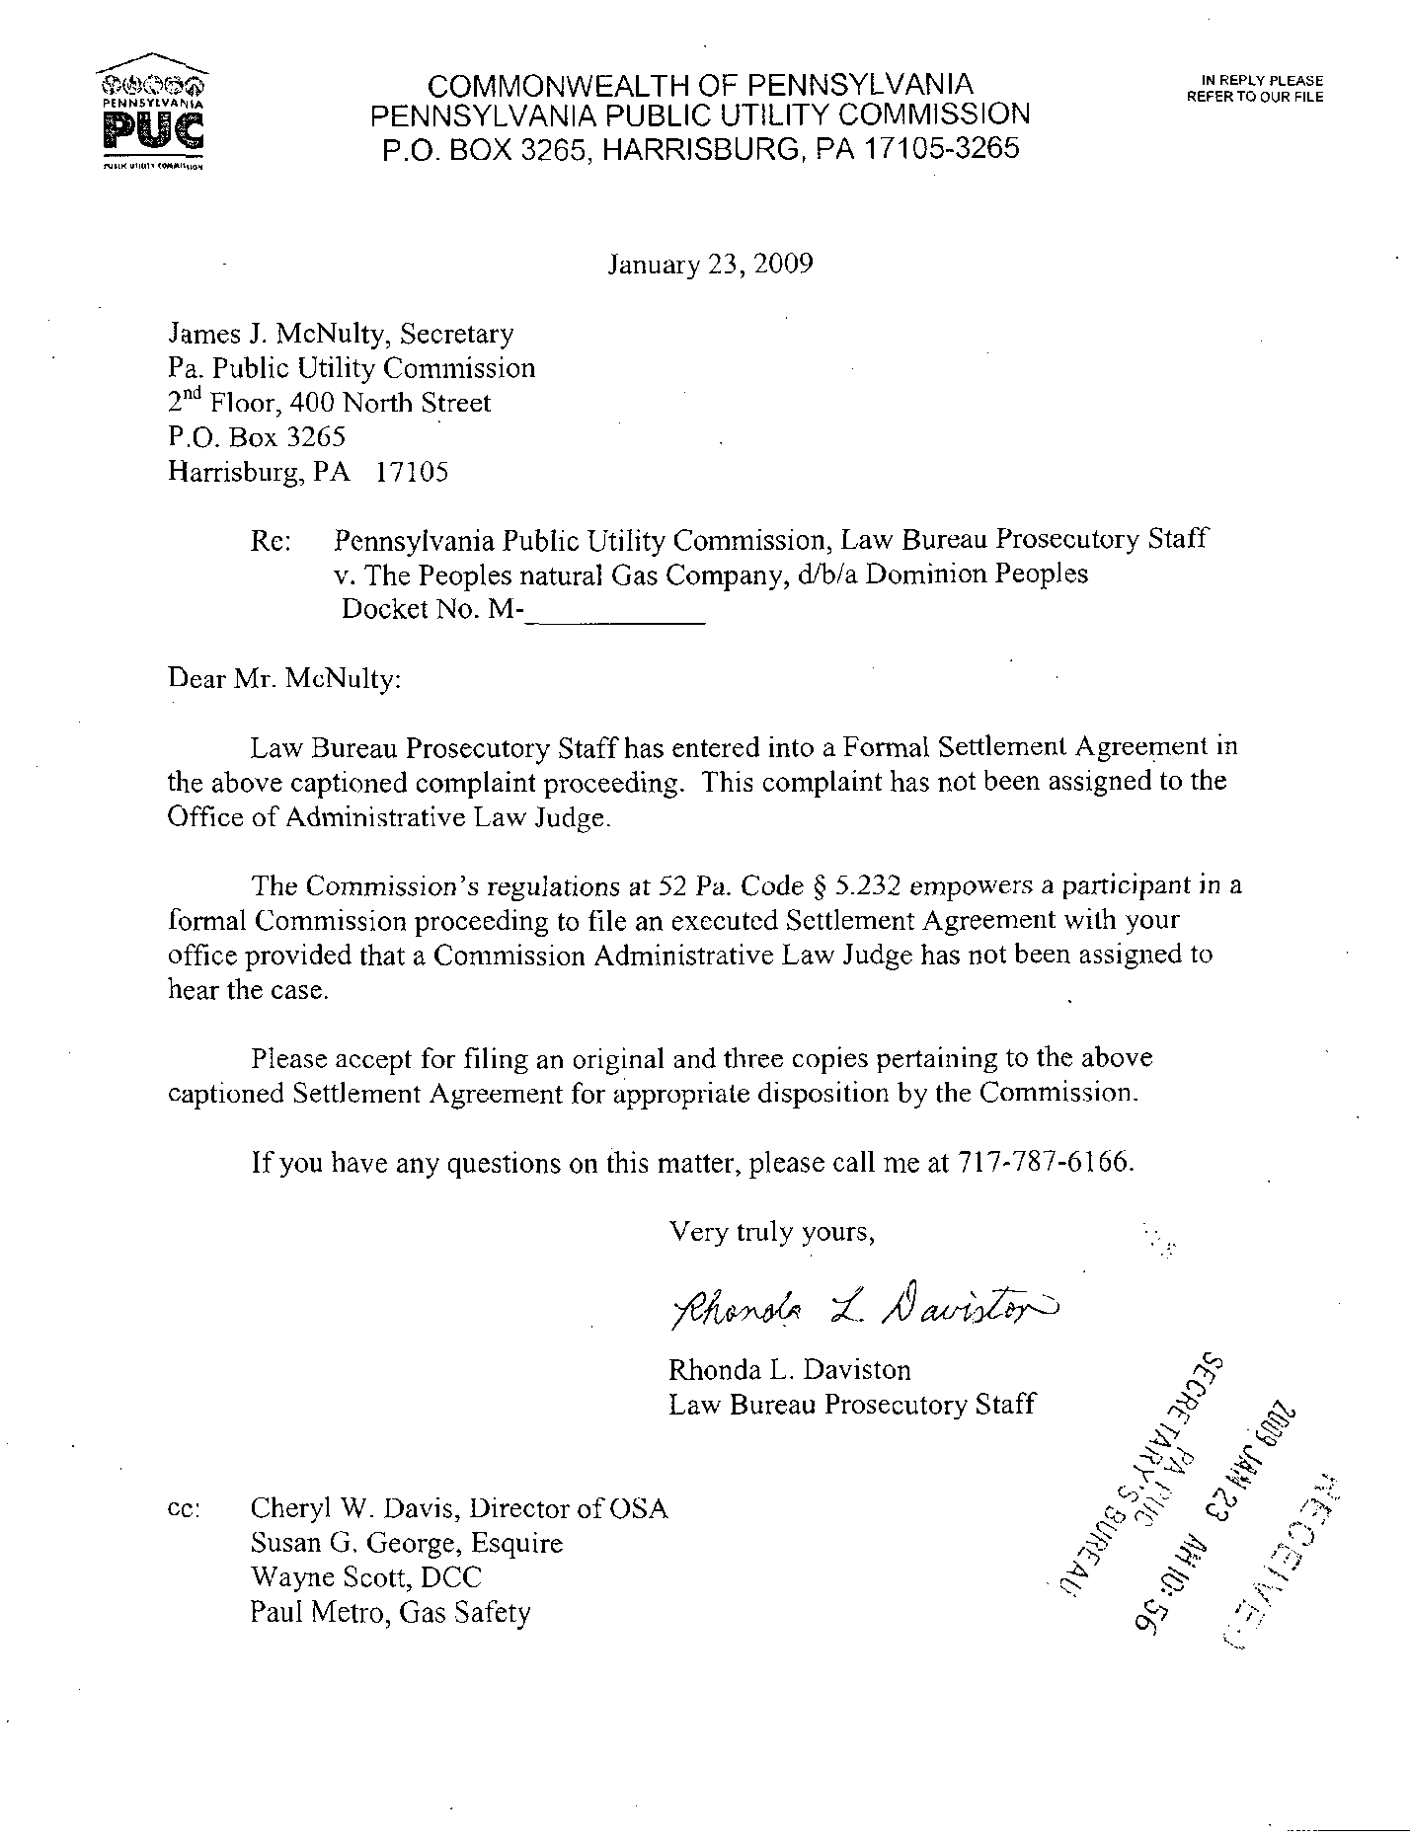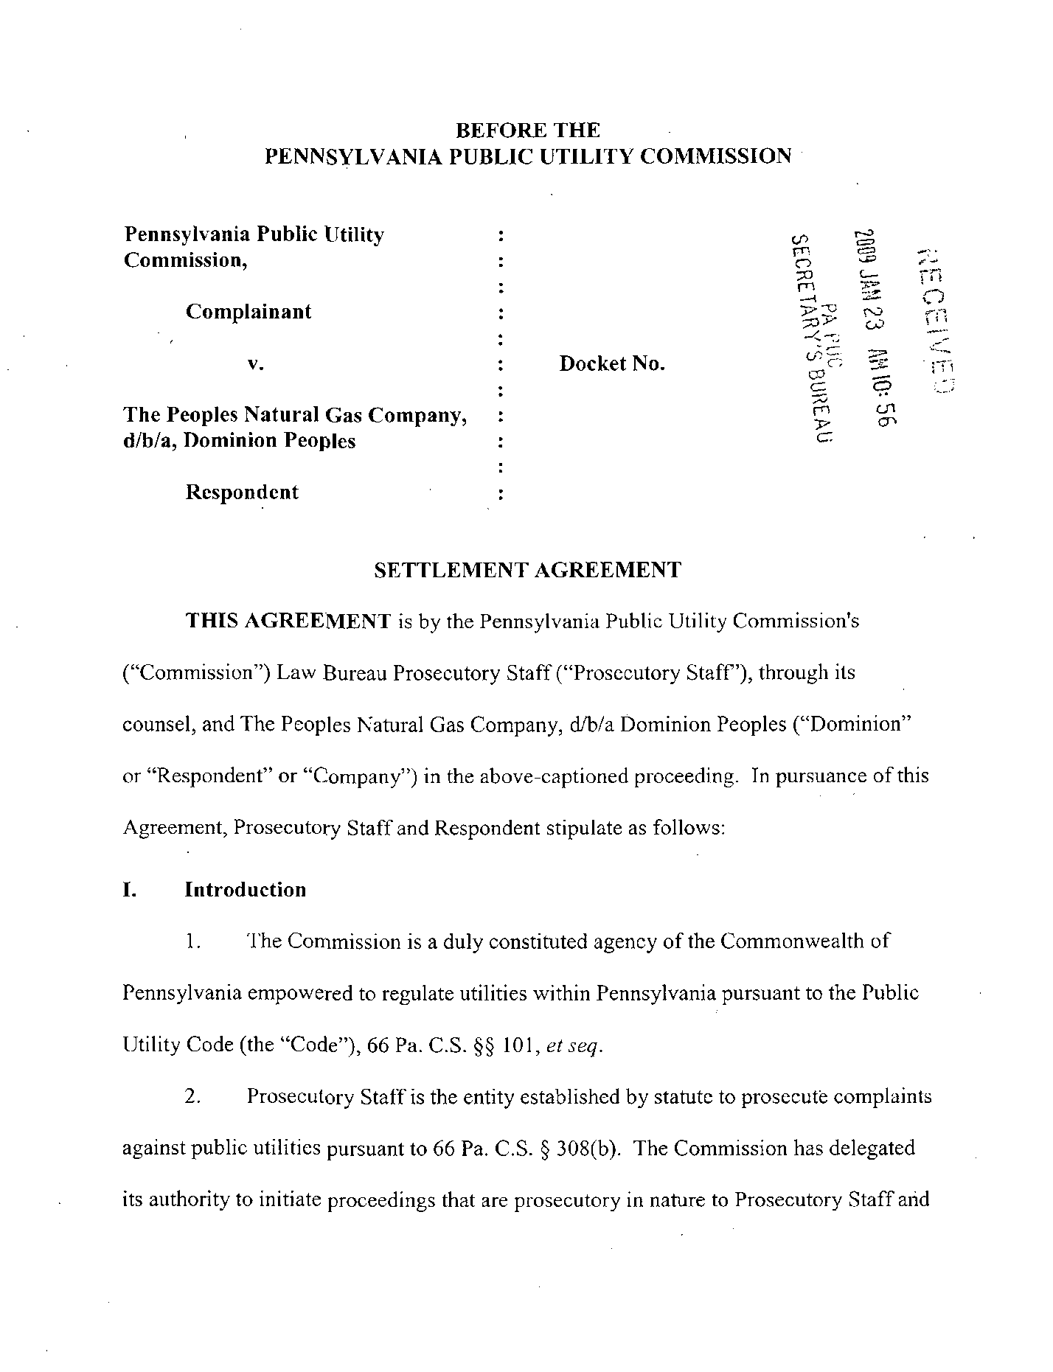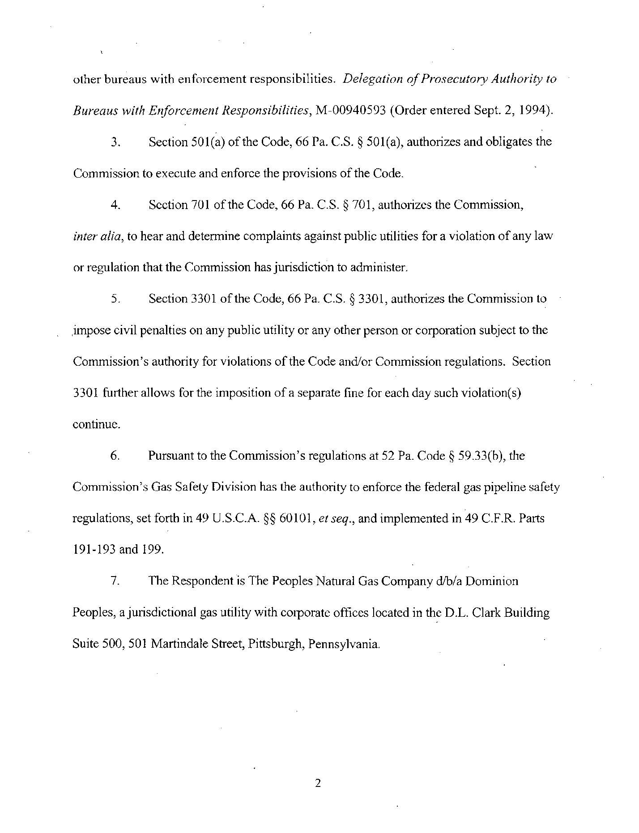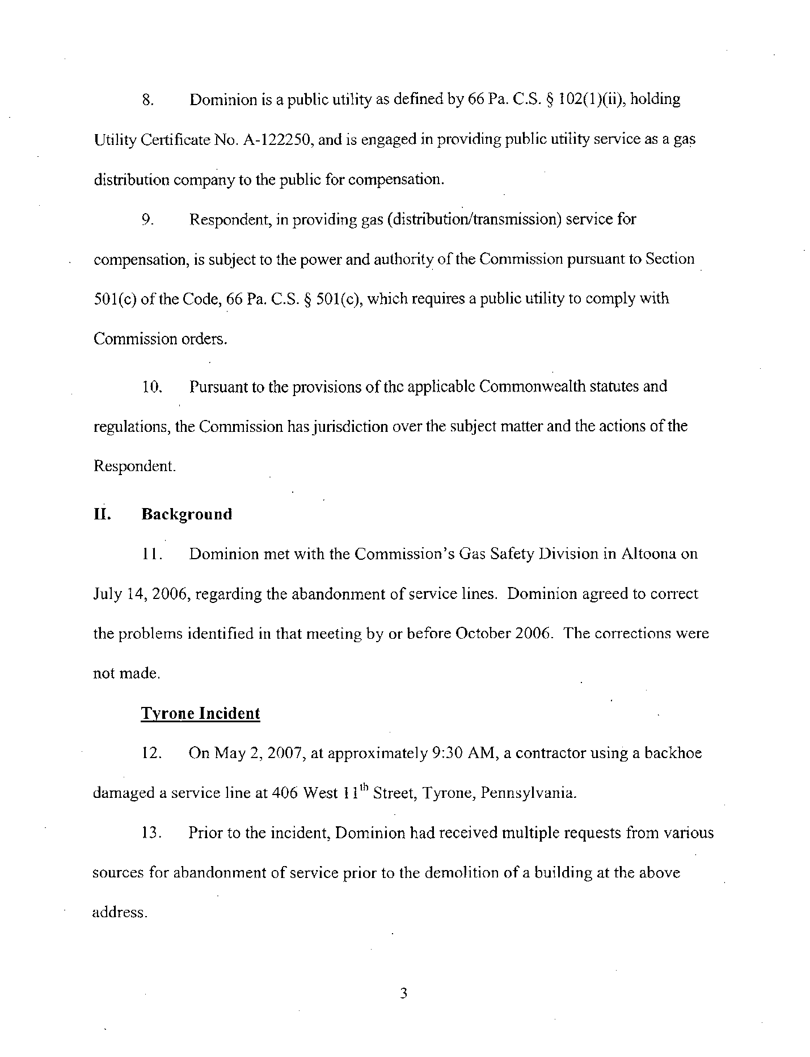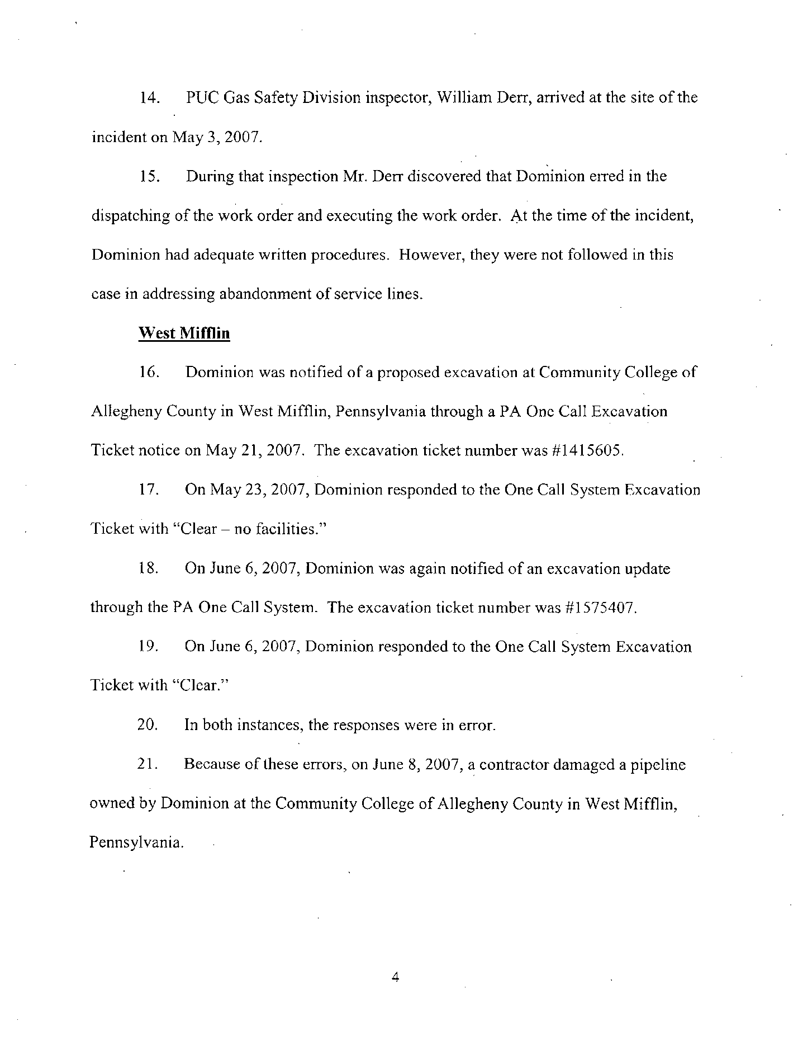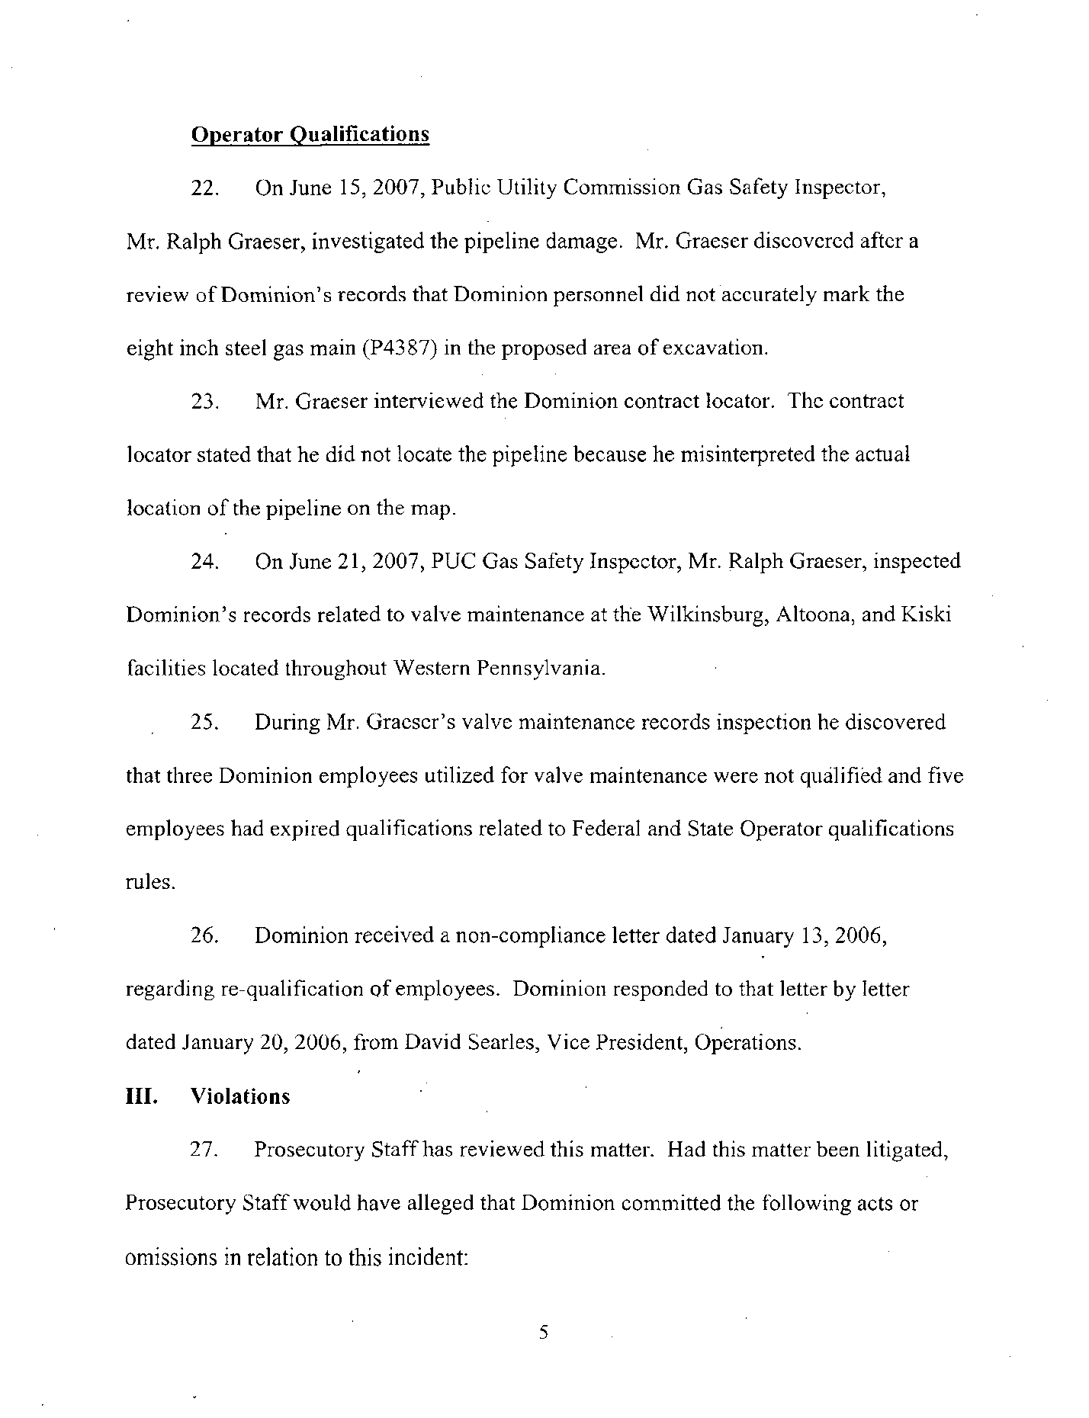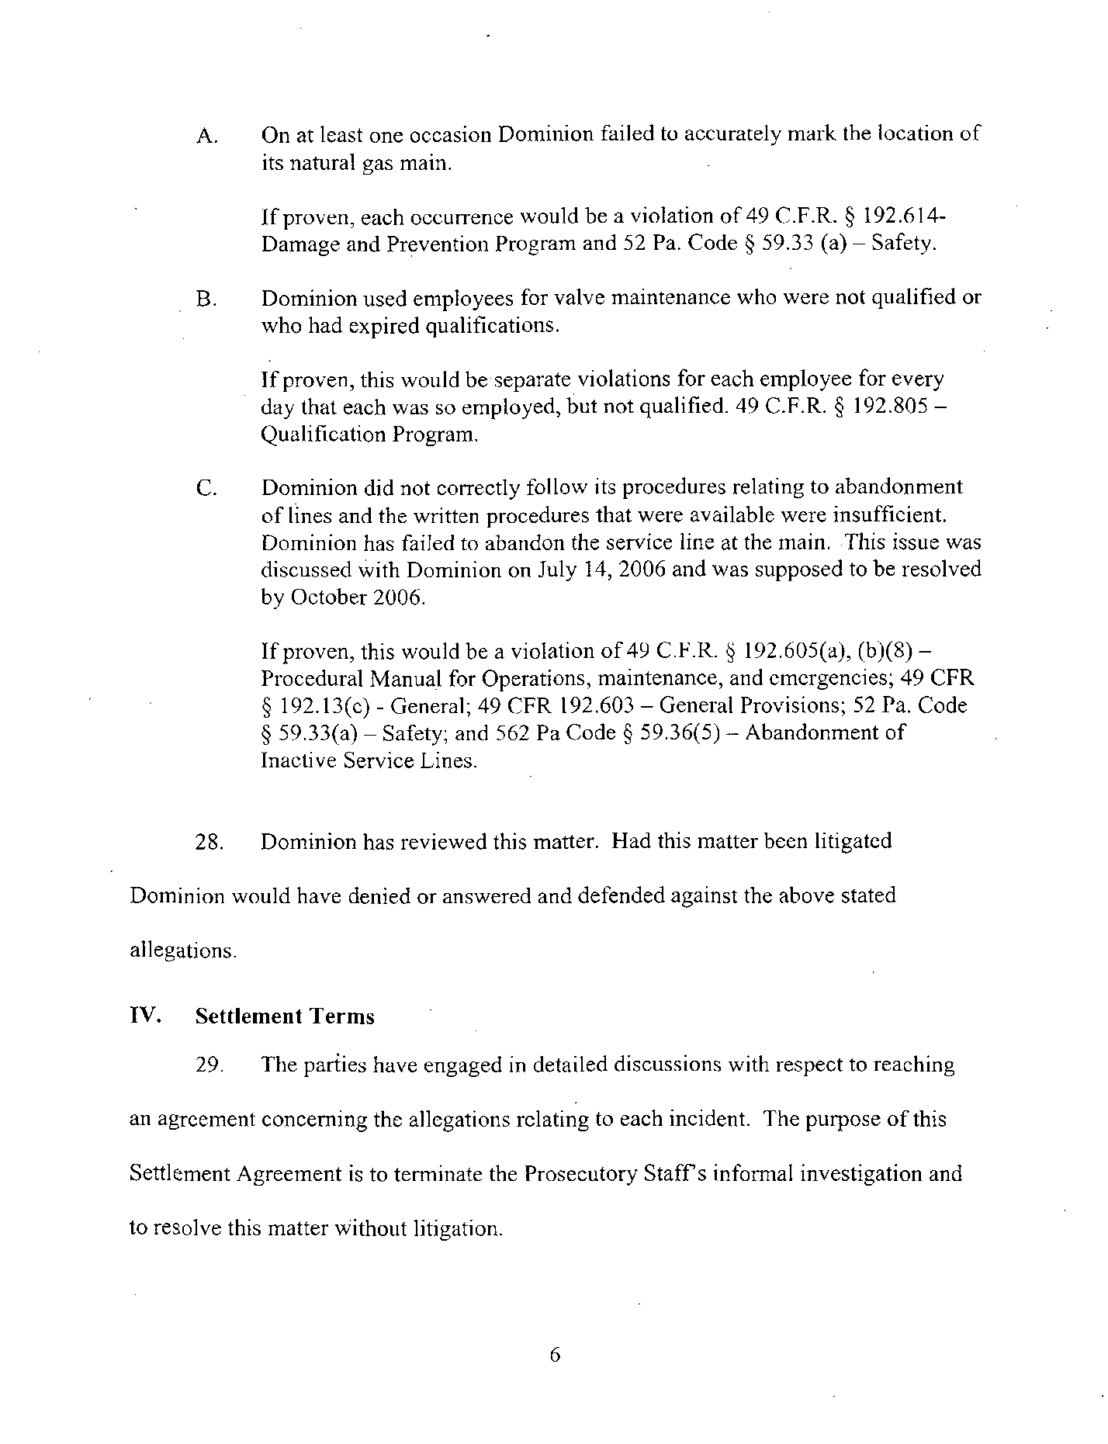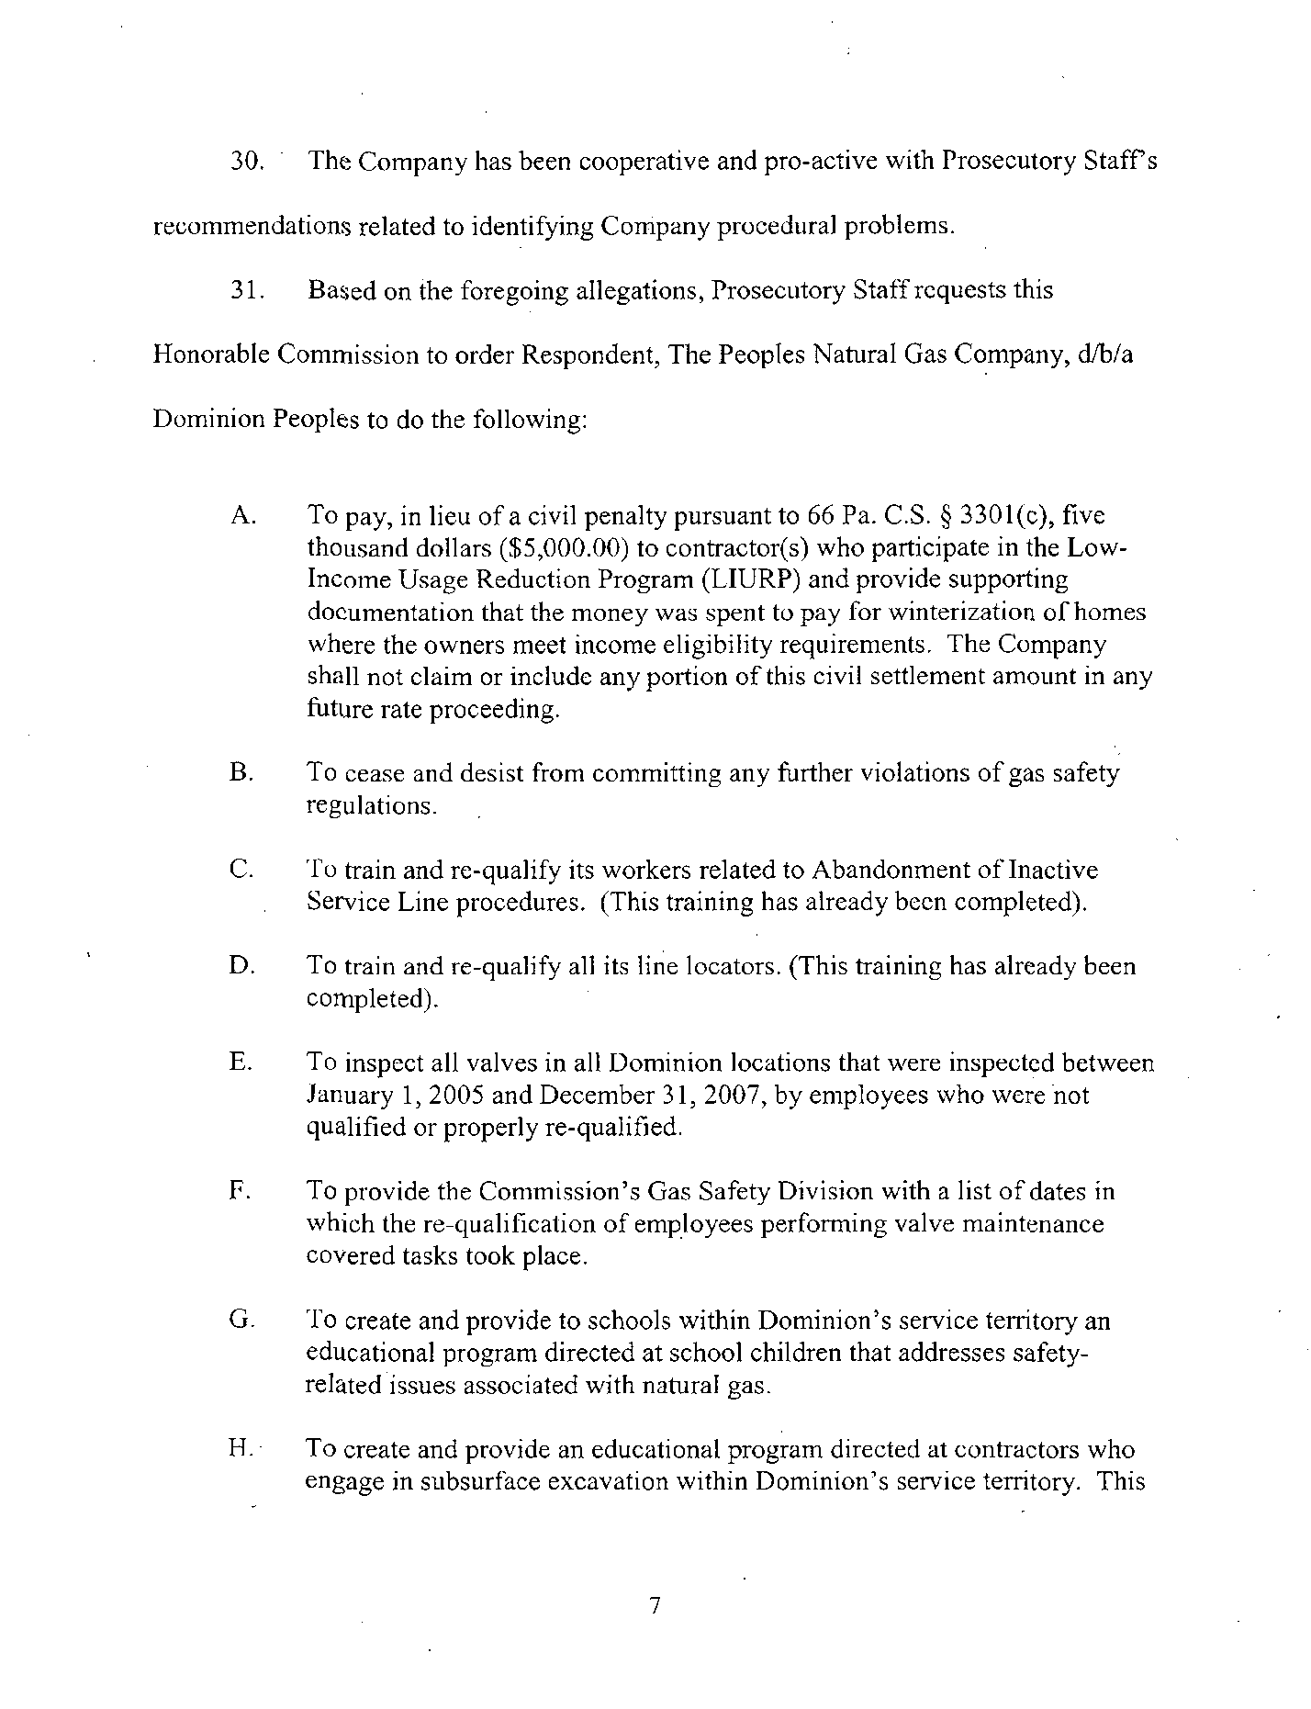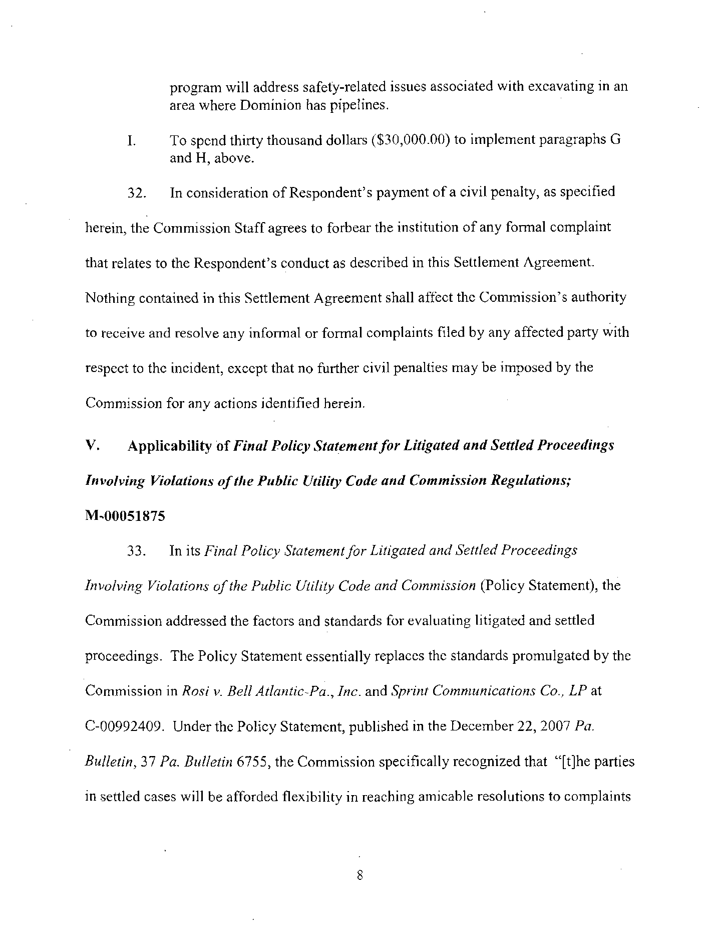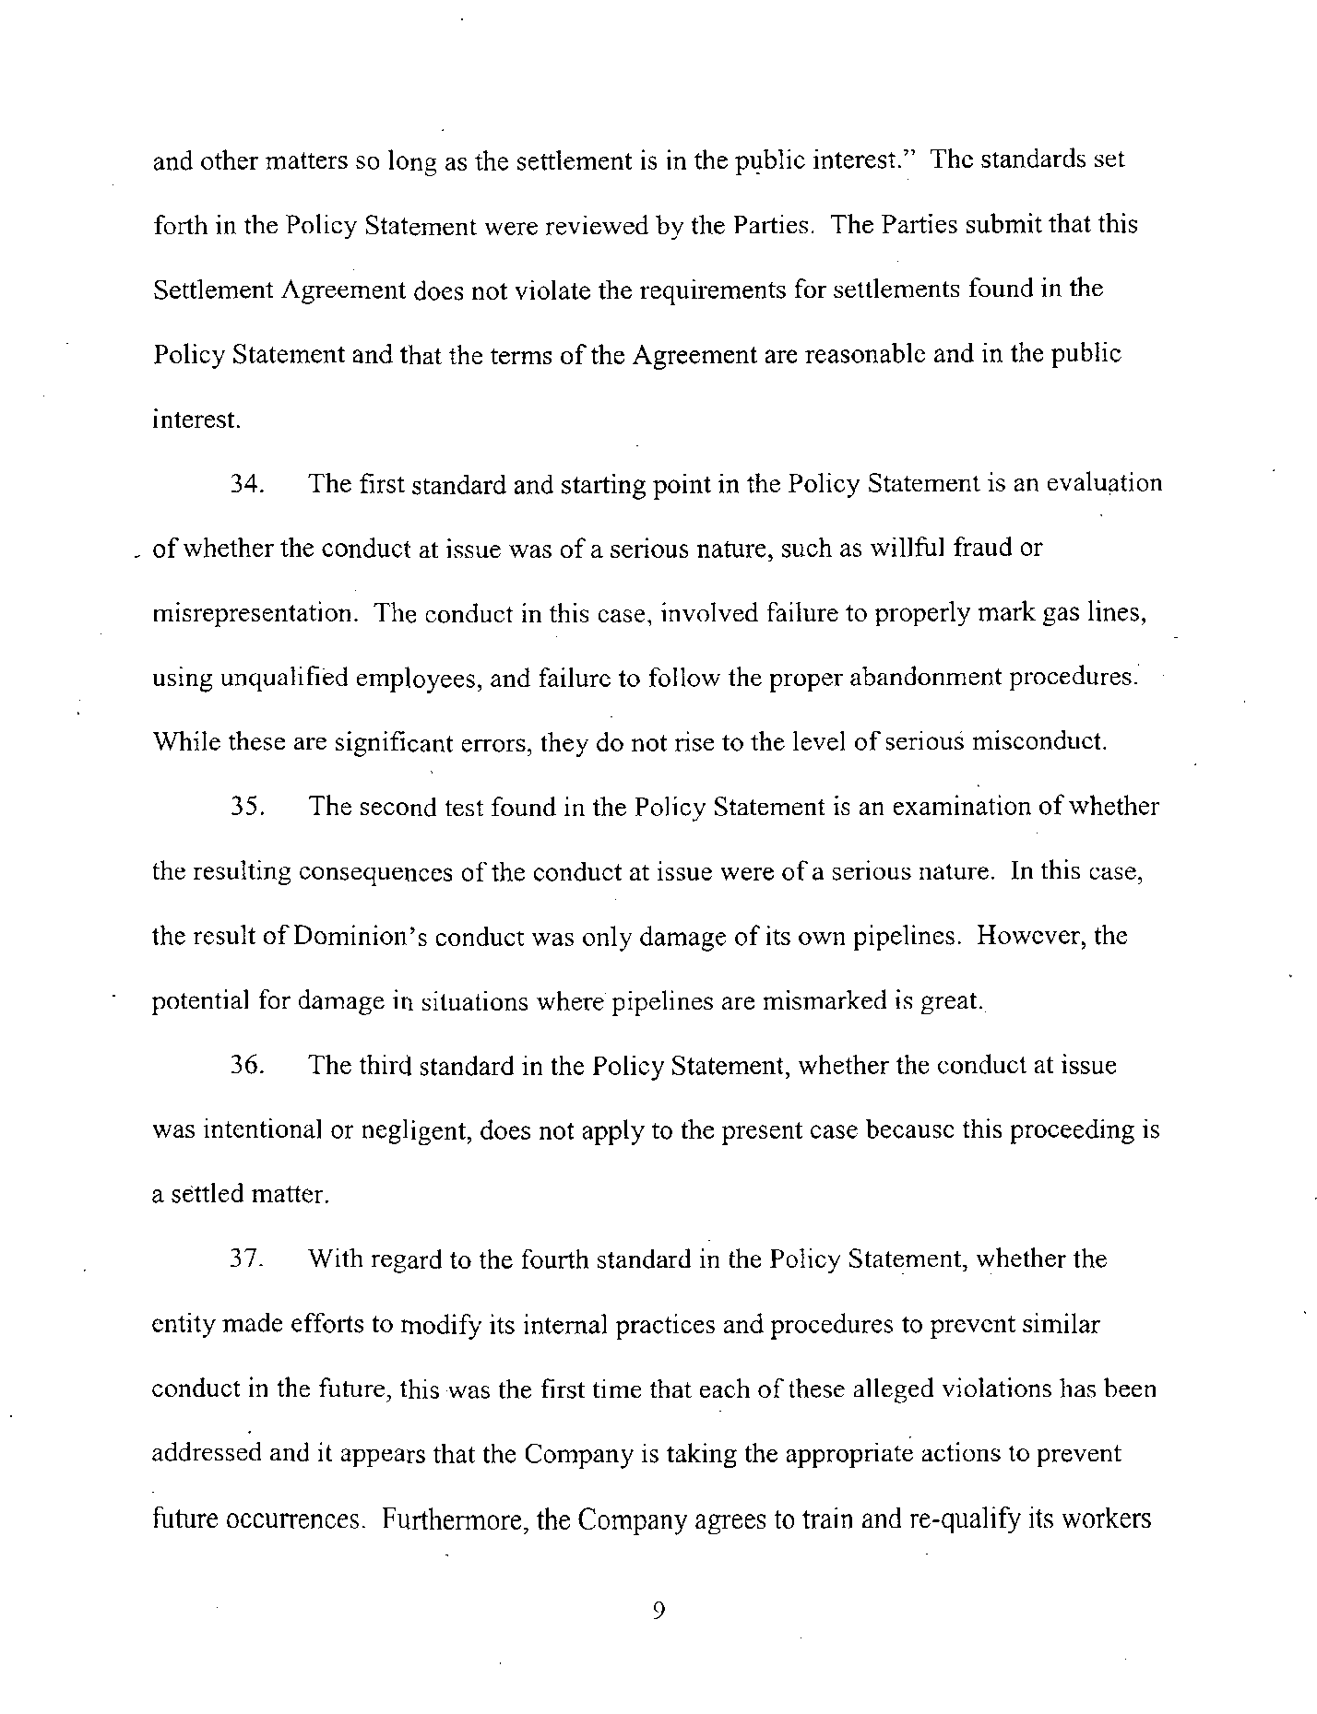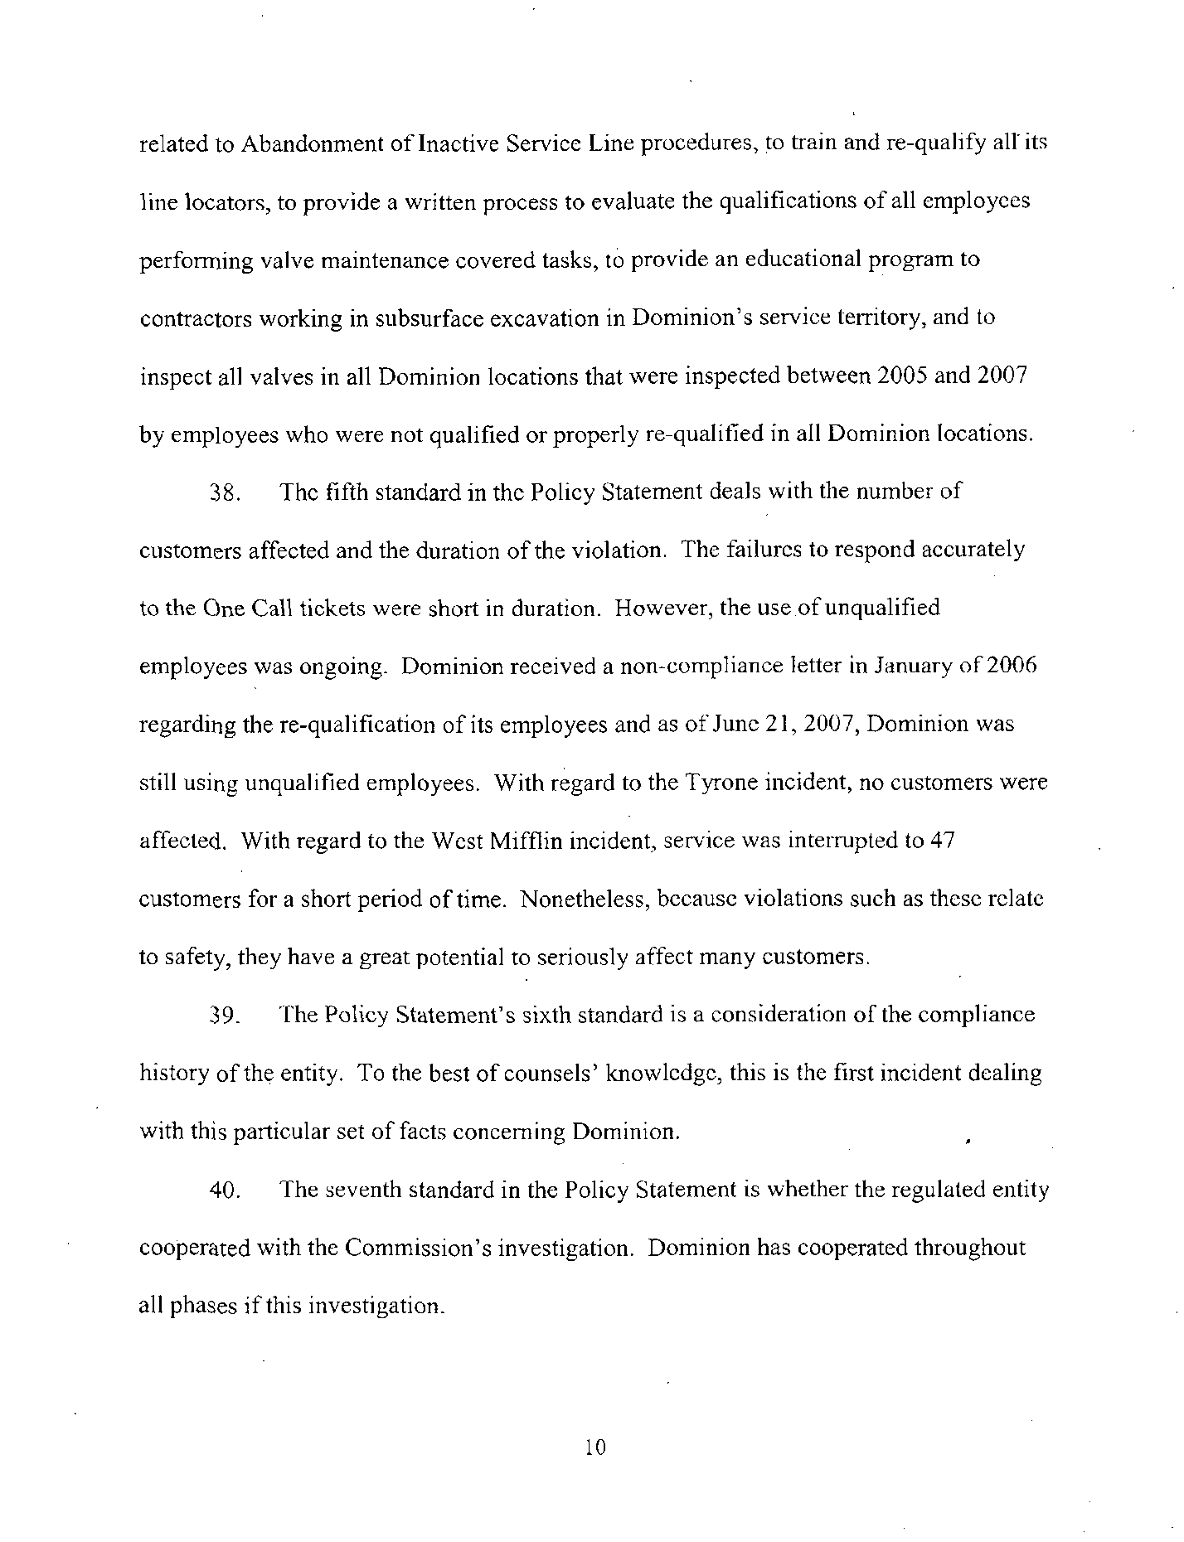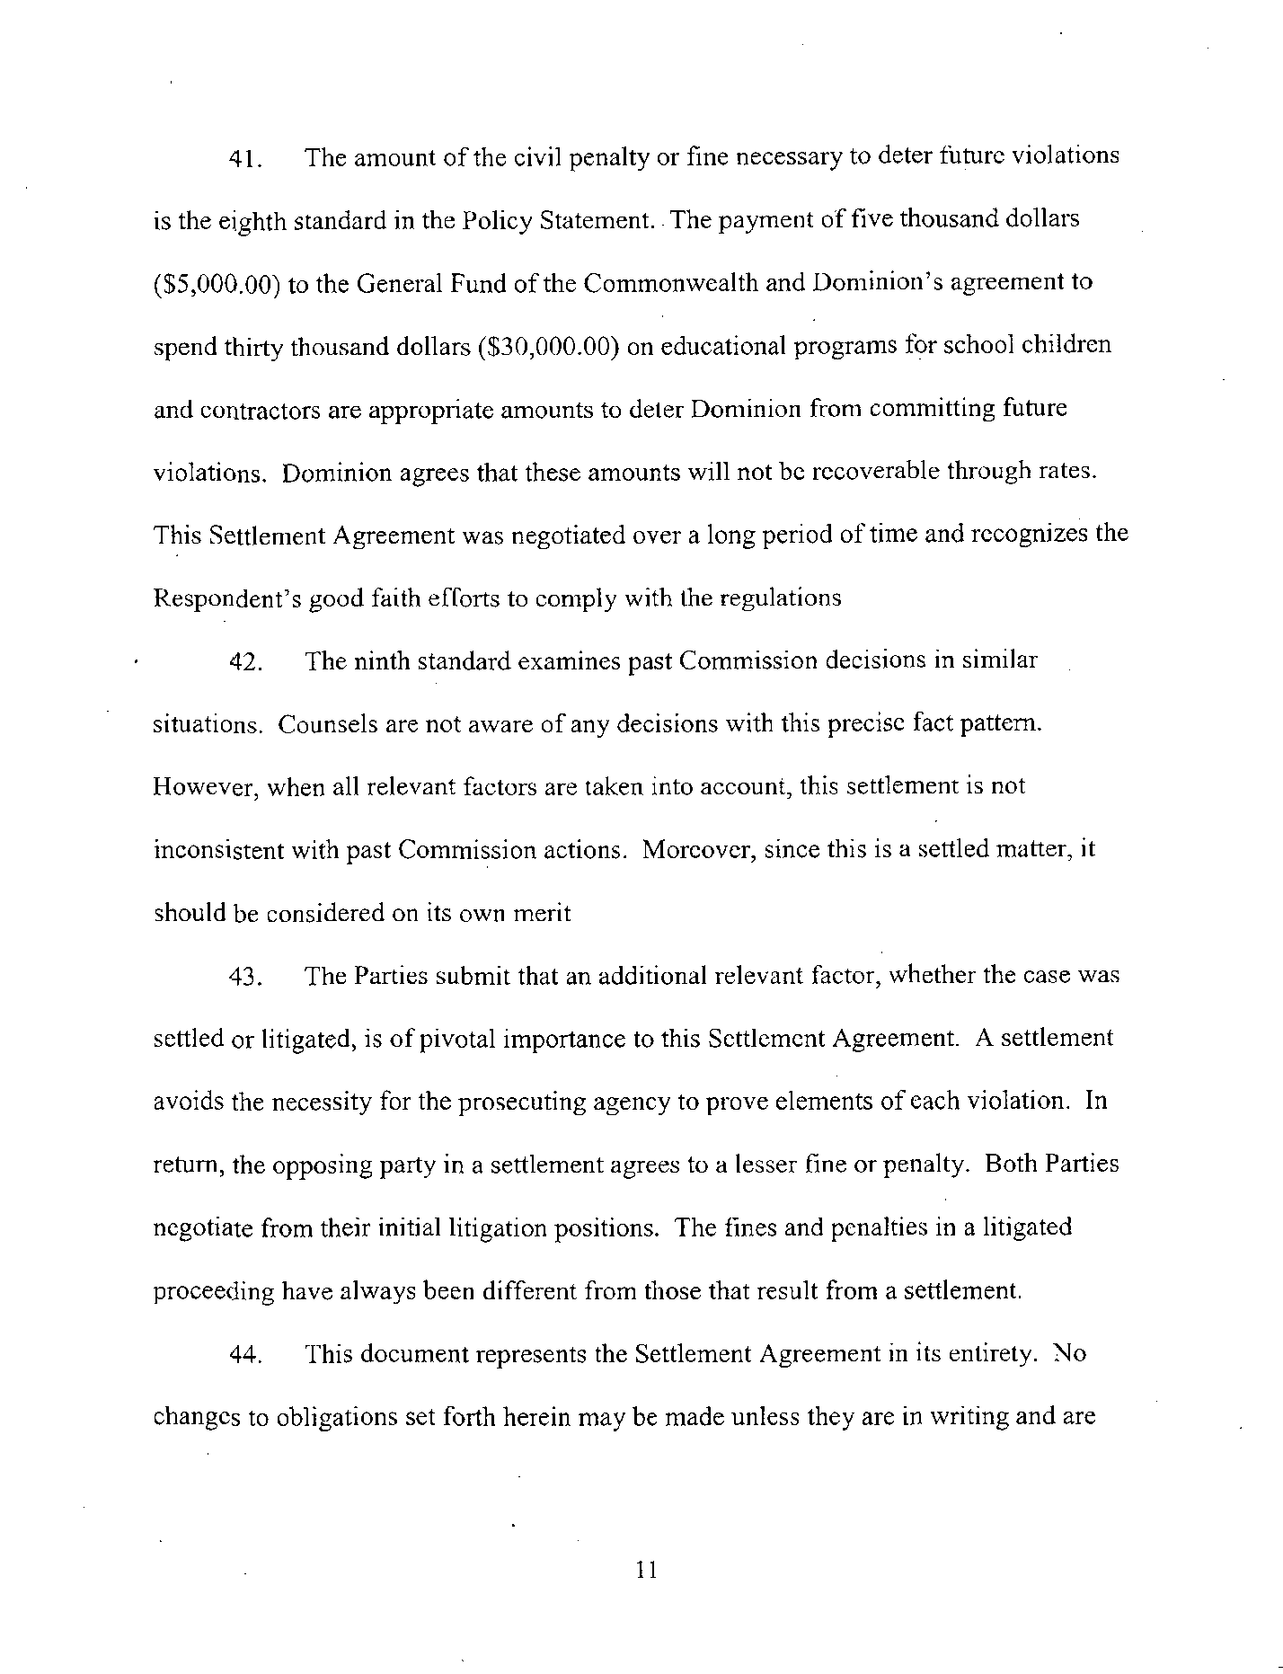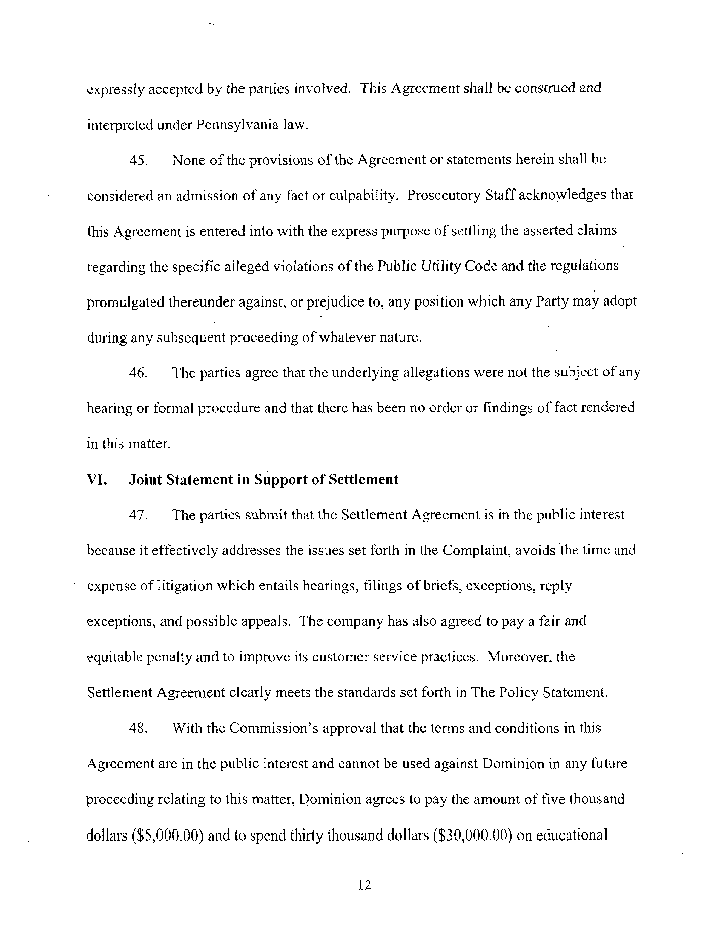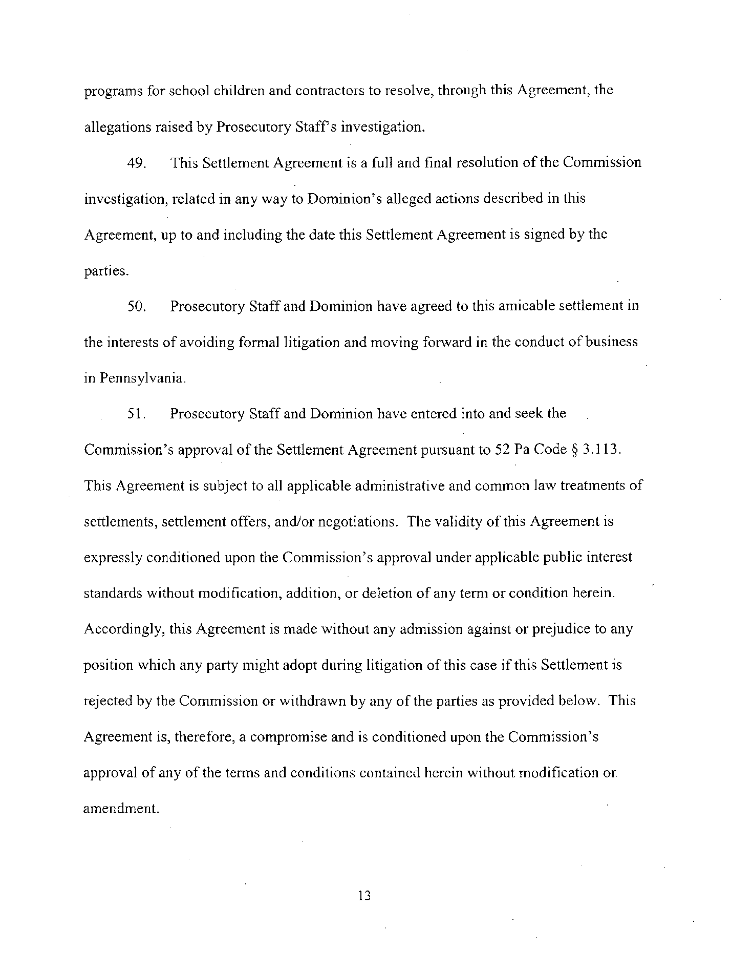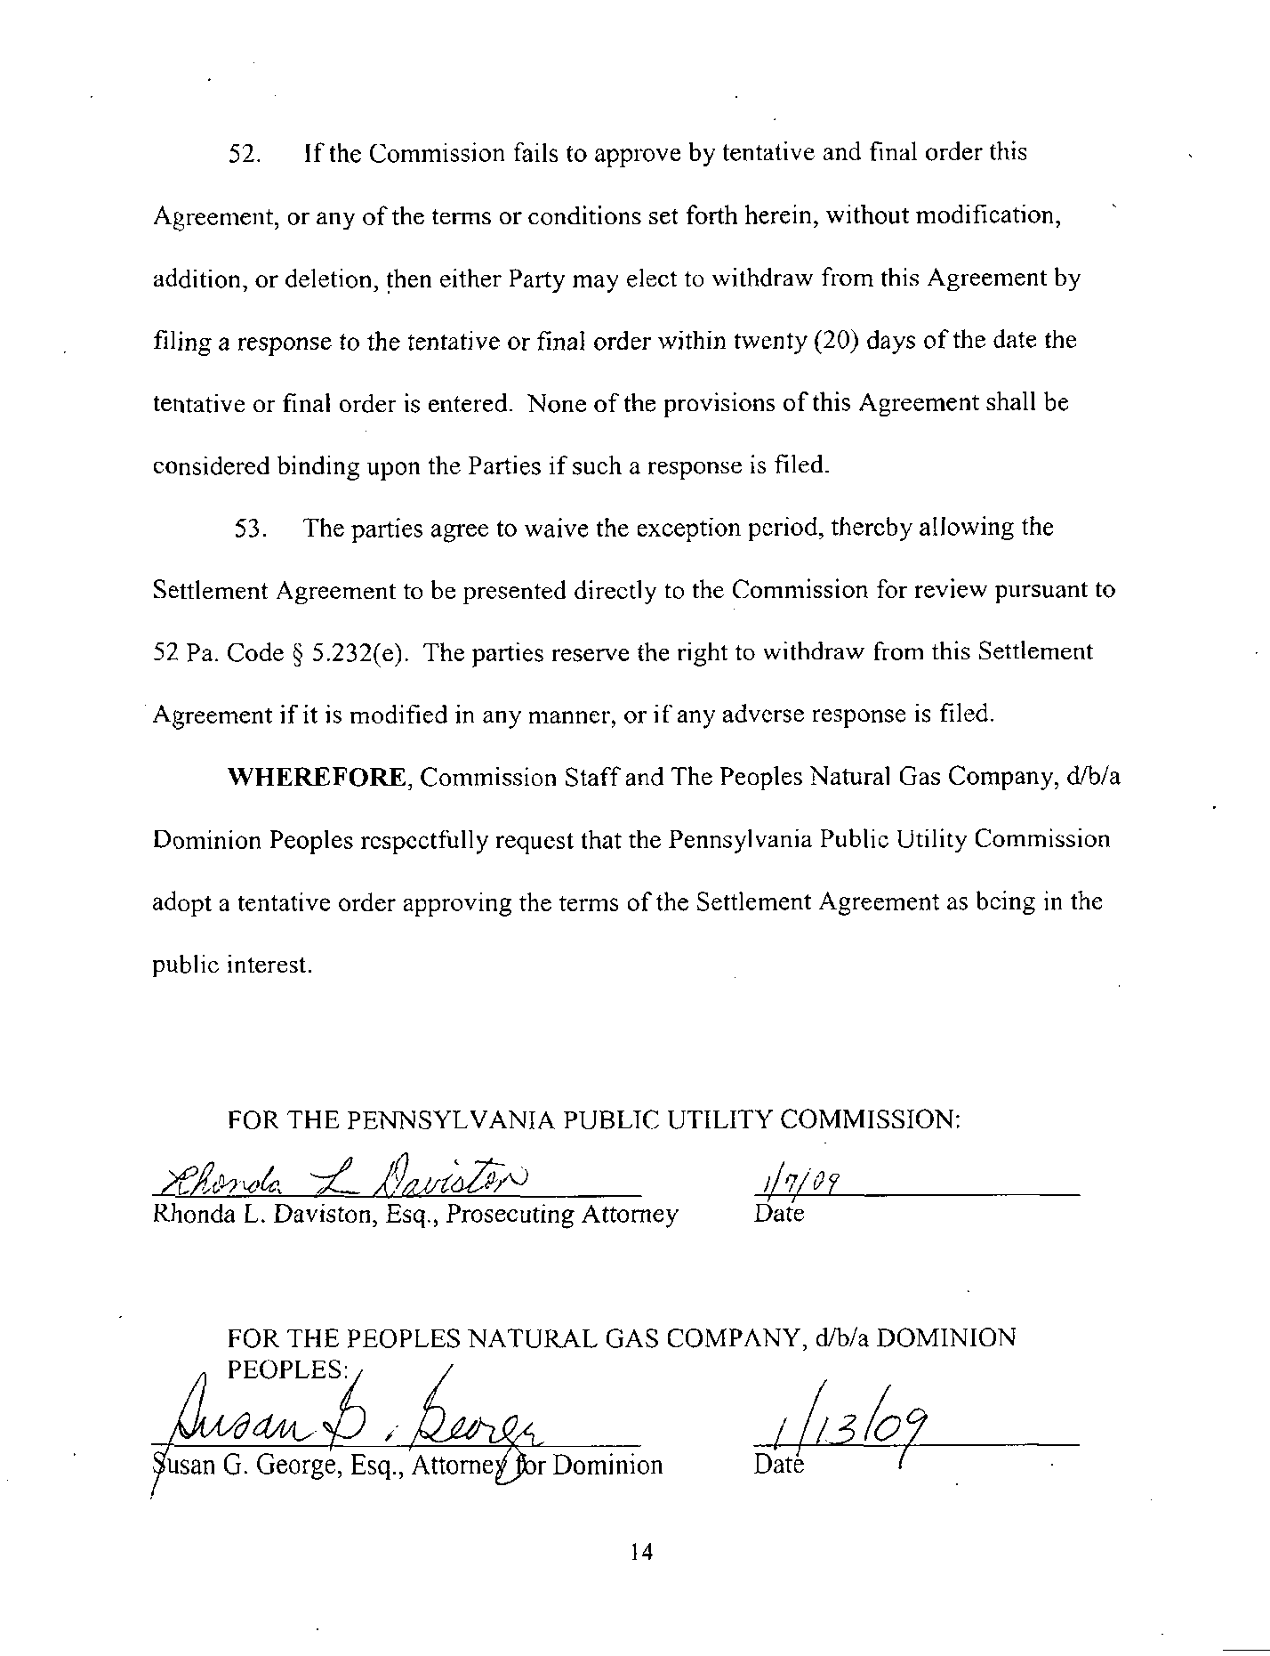

1. However, as will be discussed in this Opinion and Order, the Parties agreed to an amendment of Paragraph 31 A subsequent to the Public Meeting of May 14, 2009, but before the entry of this Opinion and Order.
2. The language in the body of this Order is the language proposed in the Motion of the Vice Chairman on May 14, 2009, which was agreed to by the Parties on May 28, 2009. The original language of the Settlement reads:

   To pay, in lieu of a civil penalty pursuant to 66 Pa. C.S. § 3301(c), five thousand dollars ($5,000.00) to contractor(s) who participate in the Low-Income Usage Reduction Program (LIURP) and provide supporting documentation that the money was spent to pay for winterization of homes where the owners meet income eligibility requirements. The Company shall not claim or include any portion of this civil settlement amount in any future rate proceeding.